Varignon’s theorem of moments
Varignon’s theorem states that moment of a resultant force about a moment centre is equal to the algebraic sum of the moments of its components about the same point.
Consider a force $F$ acting at point $A(x,y)$ at an angle $θ$. The moment of F about a perpendicular axis passing through point O,  $M_{o}=+ F×OB$  Draw lines $EC ∥ AB$, $OC⊥EC, and ED⊥AB$. $<AED=θ, <OEC=θ$  $M_{o}=F\left(OC-BC\right)=F(OC-ED)$ | E  O  A(x,y)  B  C  D
From $△OCE≫sinsin θ =\frac{OC}{OE}≫≫OC=OEsinsin θ ≫≫OC=xsinsin θ$
From $△ADE≫coscos θ =\frac{ED}{AE}≫≫ED=AEcoscos θ ≫≫ED=ycoscos θ$
$M_{o}=F\left(OC-ED\right)=F\left(xsinsin θ -ycoscos θ \right)=\left(Fsinsin θ \right) x-\left(Fcoscos θ \right) y=\left(F_{y}\right).x-\left(F_{x}\right).y$
$M_{o}=moment of F_{y} about O+moment of F_{x} about O$
Moment of resultant force $F$ about $O =$ Algebraic sum of moments of its components about O.
Exercise 1  Determine the moment of F about O. | 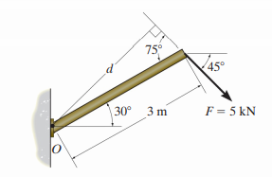
Exercise 2  Find the net moment of all forces about A | 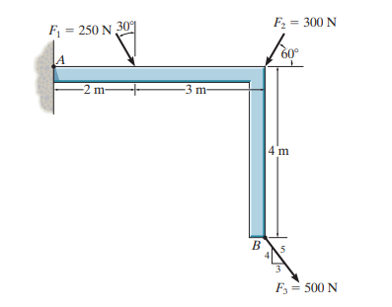

Consider a system of concurrent forces acting at $O$. Let $R$ be the resultant of the force system. If the moment of this resultant force about $A$ $\left(ΣM_{A}\right)$, when calculated, is equal to zero, it implies that either $R$ is zero or the line action of $R$ passes through $A$. If the moment of these forces about another point $B \left(ΣM_{B}\right)$, which is not in line with $OA$, is also zero, it again implies that either $R$ is zero or the line action of $R$ passes through $B$.
The resultant cannot have two lines of action; hence the resultant $R$ will be zero.
Therefore, if the algebraic sum of the moments of the concurrent forces acting at $O$ about two moment centres $A$ and $B$ are zero ($O,A,B$ are not in a line), then their resultant force is zero. That is, the conditions for equilibrium of concurrent forces are $ΣM_{A}=0$ and $ΣM_{B}=0$. We can use this condition also for equilibrium of forces.

Theorem of Three forces
Three forces can be in equilibrium if and only if they are concurrent.
This does not mean that three forces which are concurrent will always be in equilibrium.
Example 1
A beam $AB$ of weight $W=100 N$ and length $4m$ is hinged at $A$ and supported by a cable at $B$. Determine the support reaction at $A$ and tension in the cable.
Consider the free body diagram of the beam.
$ΣF_{x}=0 ≫≫X_{A}-Tcoscos 30 =0$
$ΣF_{y}=0 ≫≫Y_{A}+Tsinsin 30-100=0$
$ΣM_{A}=0 ≫≫Tsinsin 30 ×4-100×2=0 ≫≫T=100 N$
$X_{A}=+86.6 N ≪≫ Y_{A}=+50 N$
We can also solve this problem graphically. We know that the beam is acted upon by three forces; $W, T,$ and$R_{A}$. For equilibrium, these forces must be concurrent. Taking a suitable scale, draw the beam and mark the forces. The reaction $R_{A}$ should act in such a direction that it will be concurrent with the other two. Then, draw the force triangle using a suitable scale. Draw $W$ to scale. From the end points of force vector $W$,draw lines parallel to the lines of action of $T$ and $R_{A}$ to get a triangle. Mark the directions of $T$ and $R_{A}$ in such a way that it forms a closed triangle.

Example 2  Two beams $AB$ and $DE$ are loaded and supported as shown. Determine the support reactions at $A, D,$and $E$. | CC
Consider the equilibrium of beam AB.

CC

$ΣM_{A}=0 ≫≫100sinsin 30 ×5-R_{C}×3=0$
$R_{C}=83.3 N$
$ΣF_{x}=0 ≫≫X_{A}+100coscos 30 =0 ≫≫X_{A}=-86.6 N$
$ΣF_{y}=0 ≫≫Y_{A}+R_{C}30=0 ≫Y_{A}=-33.3 N$
Consider the equilibrium of beam DE.
$ΣM_{D}=0 ≫≫R_{E}sinsin 60 ×5-83.3×2=0$
$R_{E}=38.5 N$
$ΣF_{x}=0 ≫≫X_{D}-R_{E}coscos 60 =0 ≫≫X_{D}=19.5N$
$ΣF_{y}=0 ≫≫Y_{D}-R_{C}+R_{E}sinsin 60 =0≫Y_{D}=50 N$

Example 3
A cylinder of radius $r=12 cm$and weight$W=500 N$is to be pulled over a small step of height $h=6 cm$. A string is wound around the cylinder and a horizontal force $F$ is applied to the string. What is the force F just sufficient to pull the cylinder over the step?
When the cylinder is just about to be pulled over the step, there will not be any contact between the cylinder and the support at B. Hence, there will not be any support reaction at B. In the free body diagram of the cylinder, there will be only three forces, $F, W,$ and$R_{A}$. Therefore, for equilibrium, these three forces should be concurrent.
$ΣM_{A}=0 ≫≫W×AD-F×AE=0$  $500 N×10.4 cm-F×18 cm=0$  $F=288.9 N$ | $CD=r-h=6 cm$  $AD=\sqrt{{AC}^{2}-{CD}^{2}}=\sqrt{{12}^{2}-6^{2}}=10.4 cm$  $AE=CD+r=12+6=18 cm$

Exercise 1  Draw the free body diagram of the oil rig platform shown if the weight of the platform is $2000 N$. Determine the tension in the cable and reaction at the support. | 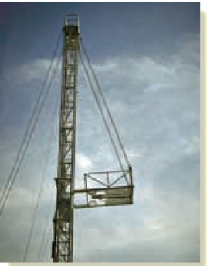 | 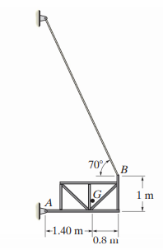
Exercise 2  A beam AB is loaded and supported as shown. Determine the support reactions. | 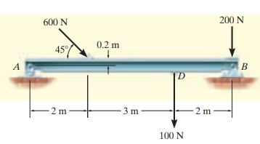
Exercise 3  A beam AB is loaded and supported as shown. Determine the support reactions at the hinged end A and roller support B. | 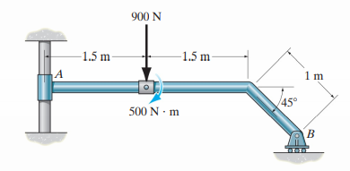

Reference
- Engineering Mechanics: Timoshenko and Young, McGraw Hill
- Mechanics for Engineers: Beer & Johnston, McGraw Hill
- Engineering Mechanics: Merriam & Kraig, Wiley
- Engineering Mechanics: Hibbeler, Pearson

